EXPT NO:6A | DATA VISUALIZATION USING POWER BI

AIM:
To import, transform, analyze, and visualize data using Power BI Desktop and create interactive dashboards and reports for decision-making.

ALGORITHM:
- Start the Power BI application.
- Import the Research Student dataset into Power BI using Get Data.
- Load the dataset into Power BI.
- Check the columns and clean the data using Power Query if required.
- Remove duplicate records and handle missing values.
- Create required calculated fields/measures.
- Create a bar chart to compare student-related categories.
- Create a pie chart to display category-wise distribution.
- Create a line chart to represent trends between numerical attributes.
- Create a card visual to display important summary values.
- Add suitable titles, labels, filters, and slicers.
- Arrange the visuals into a Power BI dashboard.
- Analyze the visualizations and identify important patterns.
- Save the Power BI report.
- Stop.

OUTPUT:
Importing
Data into Power BI:
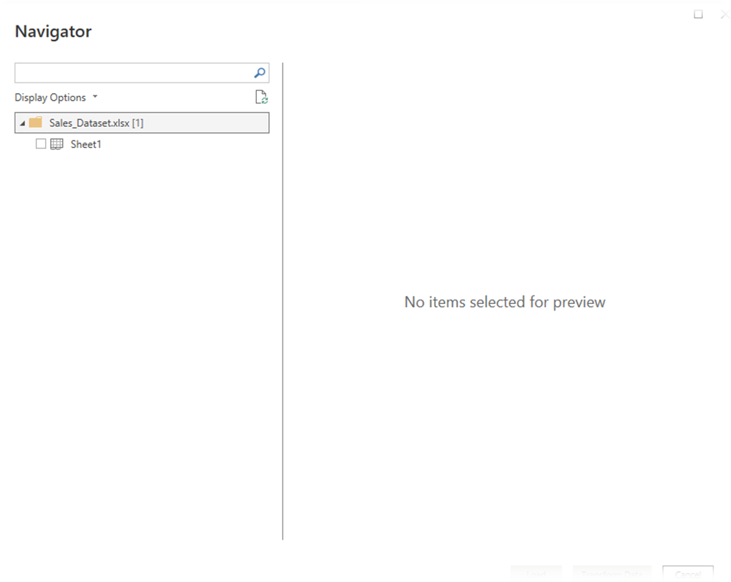

Imported dataset displayed in Data View:
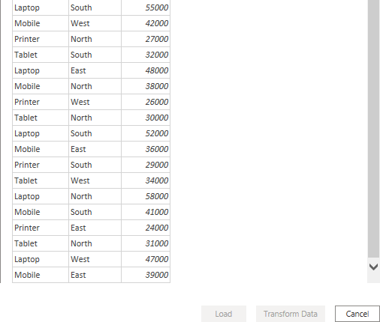

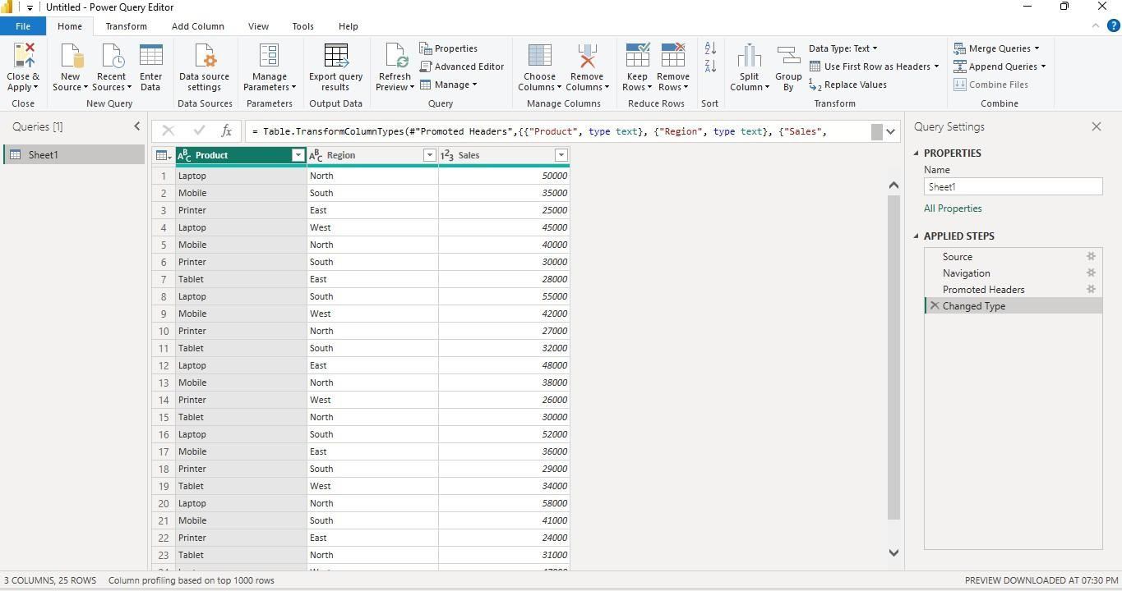
Cleaned dataset loaded successfully:
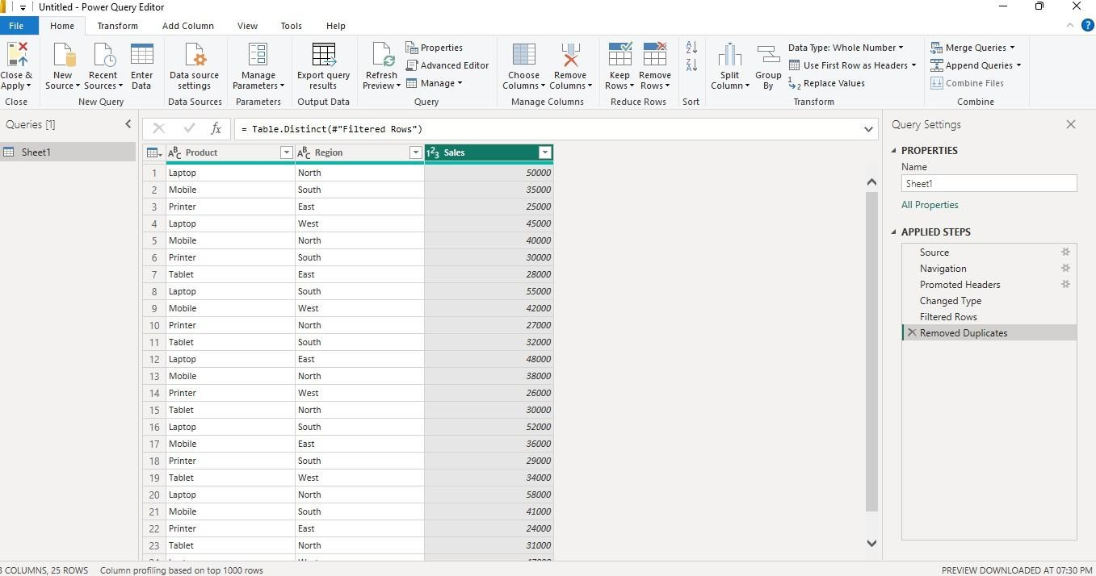
Creating a Bar Chart Product-wise Sales

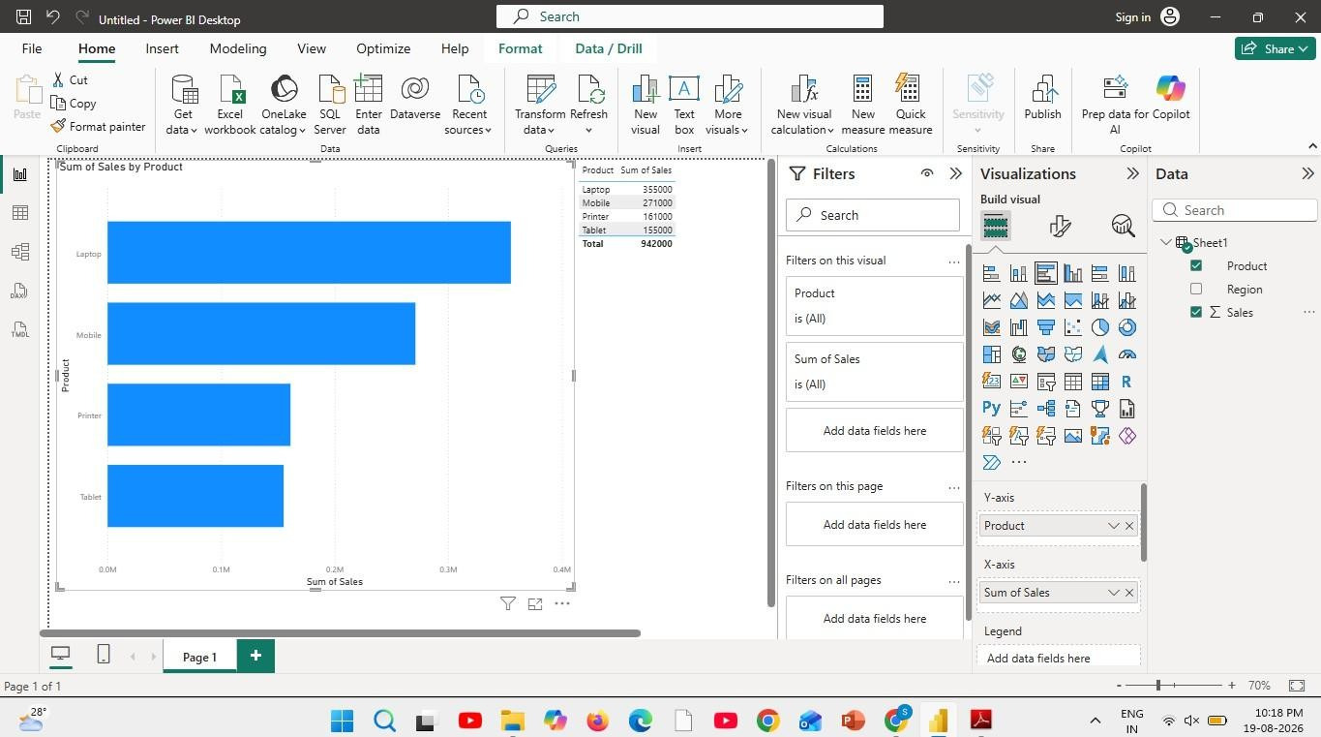
Sales comparison across products.
Creating a Pie Chart Sales Contribution
Percentage contribution of each product
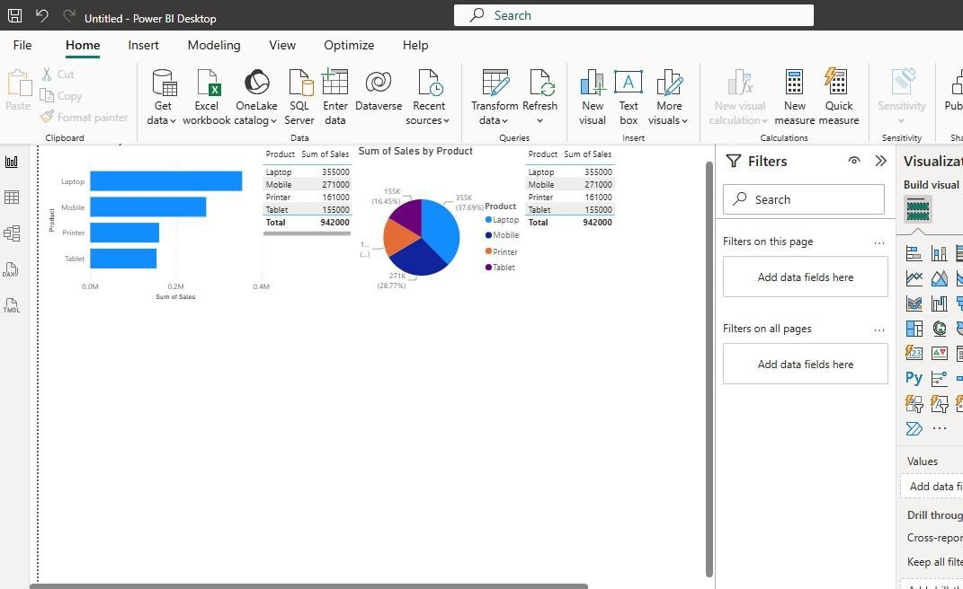

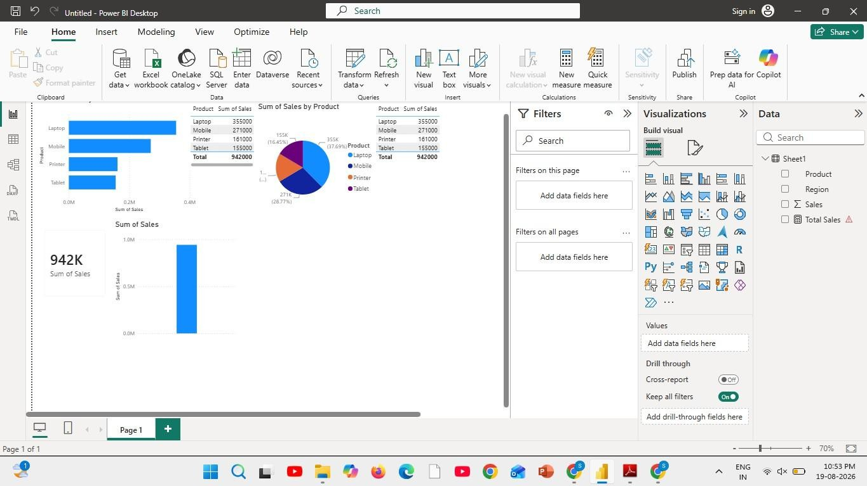
Creating a KPI Card
Creating Slicers:
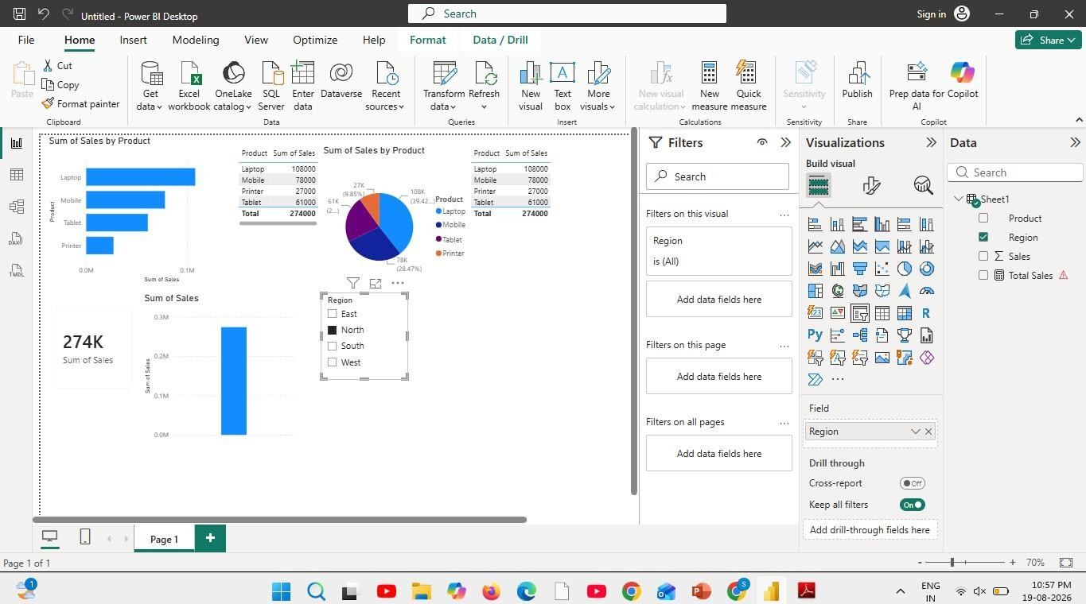
Creating DAX Calculations:

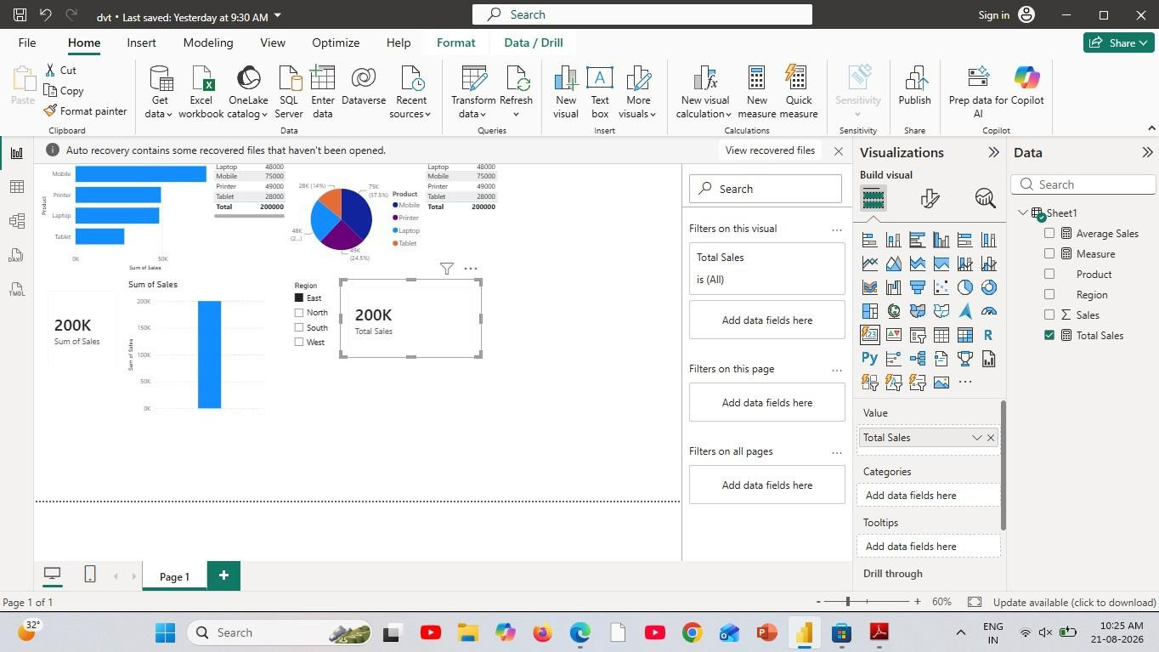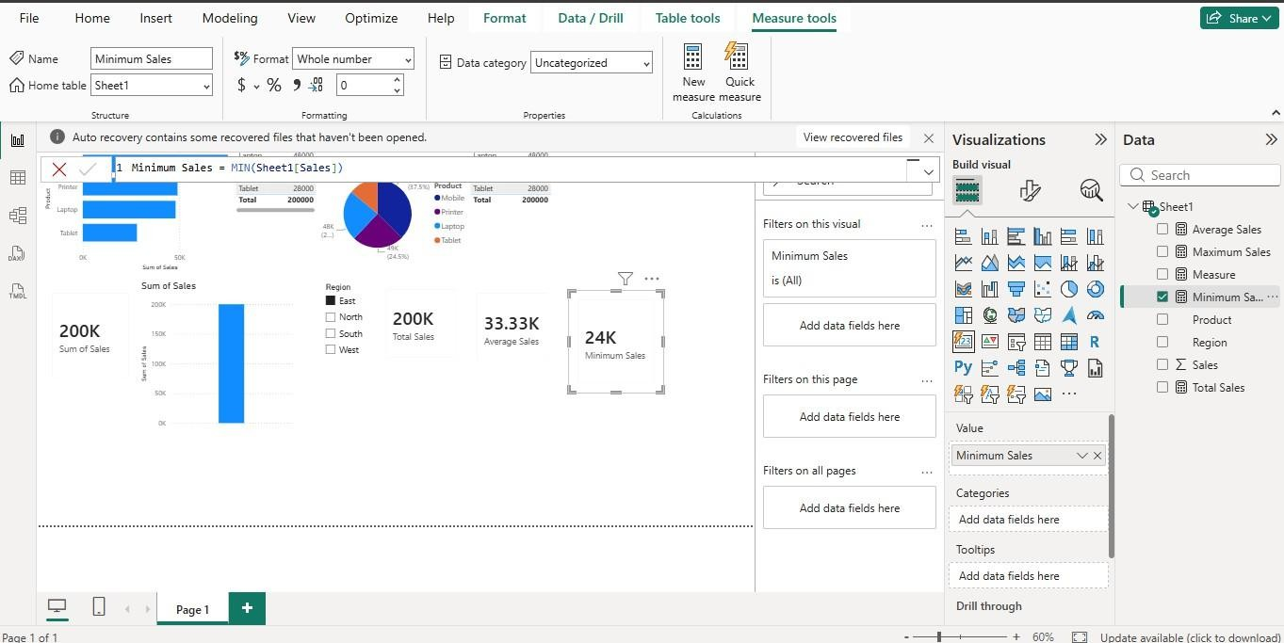

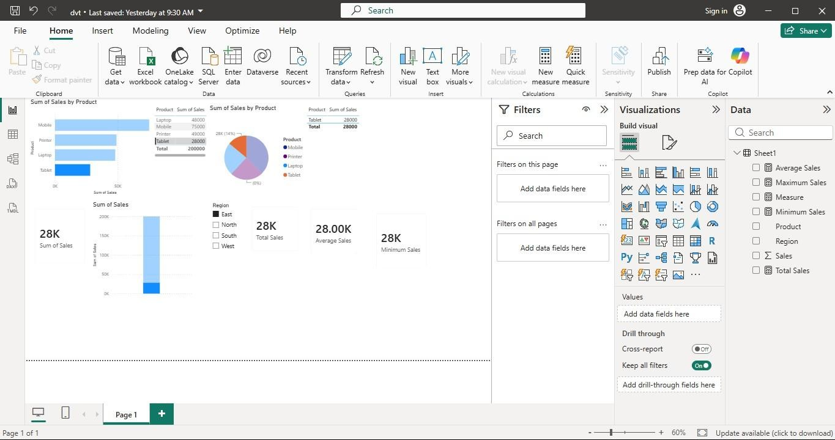
Creating Dashboard:
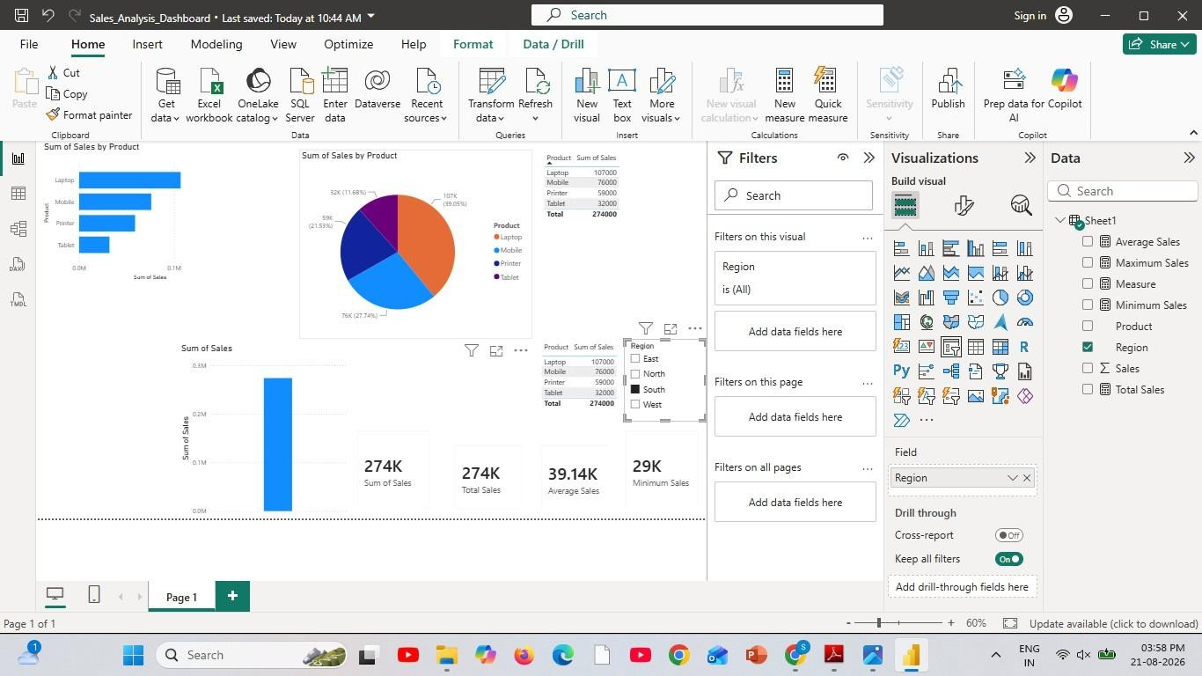

Result:

EXPT NO:6B | DATA VISUALIZATION USING POWER BI (ADVANCED STATISTICS ANALYTICS)

Aim:
To load the Global YouTube Statistics dataset into Power BI, transform and clean the data using Power Query, create calculated fields and measures, and develop interactive visualizations to analyze YouTube channels based on subscribers, video views, uploads, categories, countries, and estimated earnings.

Algorithm:
ALGORITHM 1: IMPORTING DATA INTO POWER BI
Step 1
Open Power BI Desktop.
Step 2
Select:
Home → Get Data
Step 3
Choose Text/CSV.
Step 4
Browse and select the Global YouTube Statistics CSV dataset.
Step 5
Click Load to import the dataset.
Step 6
Verify the imported columns and records in the Data View.

ALGORITHM 2: DATA TRANSFORMATION USING POWER QUERY
Step 1
Select Transform Data.
Step 2
Open the Power Query Editor.
Step 3
Check the column names and assign appropriate data types to numerical and categorical columns.
Step 4
Remove duplicate records based on the YouTube channel information.

Step 5
Handle missing or null values in columns such as Category, Country, Subscribers, Views, and Uploads.
Step 6
Clean and standardize categorical values such as Country and Category.
Step 7
Remove unnecessary columns if required.
Step 8
Click Close & Apply to load the transformed dataset into Power BI.

ALGORITHM 3: ADVANCED DATA TRANSFORMATIONS
Step 1
Select the Subscribers column and ensure that it has an appropriate numeric data type.
Step 2
Select the Video Views column and convert it into a numeric data type.
Step 3
Select the Uploads column and convert it into a whole number.
Step 4
Check columns related to Year, Month, or Channel Creation Date and convert them into appropriate date or numeric formats.
Step 5
Handle missing values in numerical columns by replacing them appropriately or filtering invalid records.
Step 6
Create additional categories or groups where required, such as subscriber ranges for comparing small, medium, and large YouTube channels.
Step 7
Click Close & Apply to load the cleaned dataset into the Power BI model.

ALGORITHM 4: CREATING CALCULATED COLUMN AND MEASURES
Step 1
Navigate to Report View or Table View.
Step 2
Right-click the dataset table and select New Column.
Step 3
Create a calculated column to determine the average views per uploaded video:

Average Views per Upload =
DIVIDE([Video views], [Uploads], 0)
Step 4
Create a measure to calculate total subscribers:
Total Subscribers =
SUM([subscribers])
Step 5
Create a measure to calculate total video views:
Total Video Views =
SUM([video views])
Step 6
Create a measure to calculate the total number of uploads:
Total Uploads =
SUM([uploads])
Step 7
Create additional measures such as average subscribers or average video views for further analysis.

ALGORITHM 5: DASHBOARD VISUALIZATION & REPORTING
Step 1
Select a Line Chart and map the available Year/Date field to the X-axis and Subscribers or Video Views to the Y-axis to analyze trends.
Step 2
Select a Bar/Column Chart and map Country or Category to the X-axis and Subscribers or Video Views to the Y-axis.
Step 3
Select a Donut/Pie Chart to display the distribution of YouTube channels based on Category or Country.
Step 4
Select a Bar Chart to identify the Top YouTube Channels by Subscribers.
Step 5
Create another chart to identify the Top YouTube Channels by Video Views.
Step 6
Add Card Visuals to display important summary values such as:
- Total YouTube Channels
- Total Subscribers
- Total Video Views

Step 7
Add Slicer visuals for Country, Category, and Year to enable interactive filtering.
Step 8
Arrange all the visuals into a meaningful and interactive YouTube Analytics Dashboard.
Step 9
Add suitable titles, labels, legends, and formatting to improve the readability of the dashboard.
Step 10
Analyze the dashboard to identify patterns such as the most popular channels, leading countries, dominant categories, subscriber distribution, and video-view trends.
Step 11
Save the Power BI report as a .pbix file.

Output:
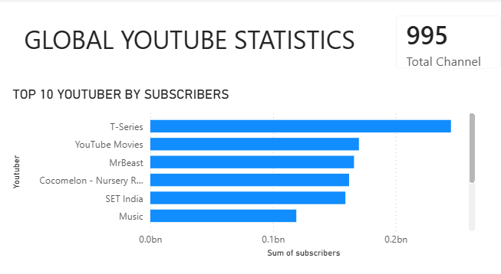

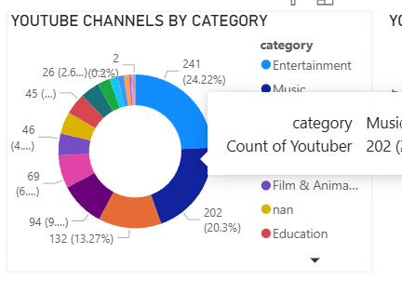

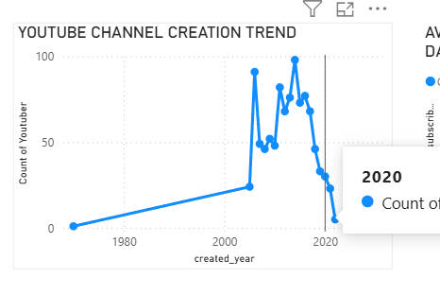

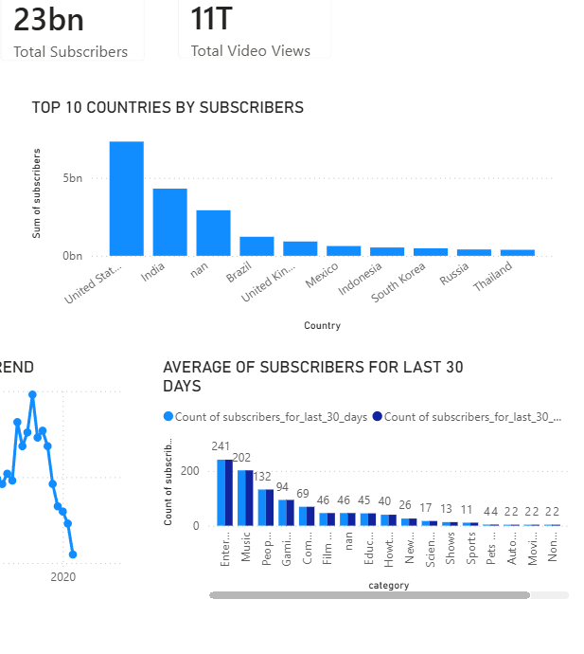

Result:

EXPT NO:6C | DATA VISUALIZATION USING POWER BI (HOTEL BOOKING)

Aim:
To clean, preprocess, and transform the raw hotel_bookings dataset, load the clean data model into Power BI, and build an interactive visual dashboard to analyze booking trends, cancellation patterns, guest demographics, and pricing metrics.

Algorithm:
- Import Dataset: Load hotel_bookings.csv into your environment.
- Deduplication: Identify and delete duplicate rows across all fields
- Drop High-Missing Columns: Remove the company column due to excessive missing/null data.

Impute Missing Values:
Replace missing values in agent with 0 (or median). Replace missing values in country with "PRT" (mode). Replace missing values in children with 0.
- Handle Data Type & Syntax Errors:

Replace text anomalies (like "NA" strings) in numeric columns (children, adr) with
0 to prevent load errors.

Format reservation_status_date as Date, children / agent as Whole Number, and adr as Decimal.

- Load Clean Data: Load the cleaned table into Power BI Desktop via Get Data > Text/CSV (or click Apply & Close from Power Query Editor).

Create Core Metric:
Right-click the table name → Select New Measure.
Define measure: Total Bookings = COUNTROWS(hotel_bookings)

Output:

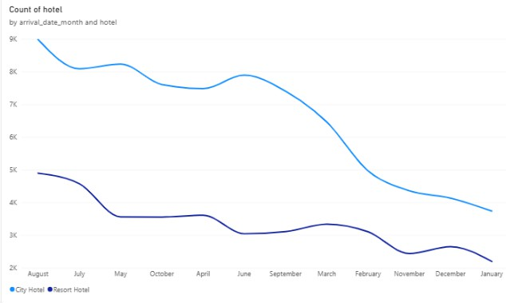

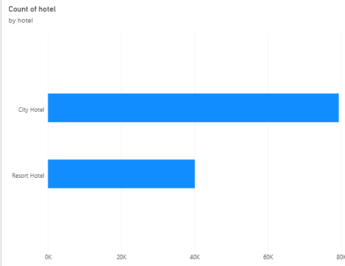

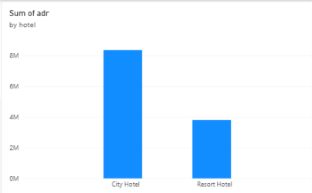

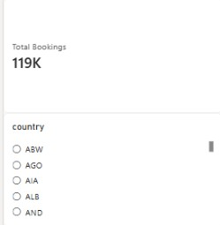

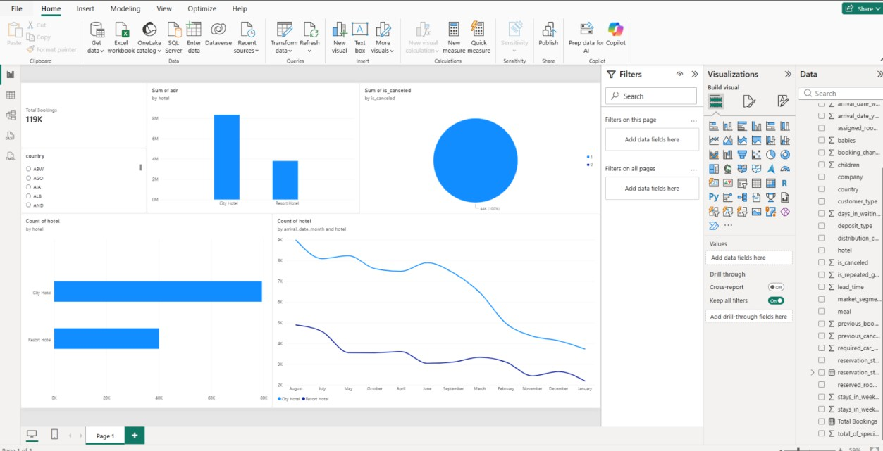

Result:

